Spike Gate Samples Explained
Narrative guide to the bar-major profile spike gate used by bar_spike_gated_foreground_report.py.
One-sentence summary: the spike gate marks narrow, local, off-centre brightness peaks in the bar-major profile, then keeps only foreground-candidate mask segments that intersect those marked profile samples.

Why the spike gate exists
Foreground stars and compact artefacts often appear as narrow positive spikes when the galaxy image is sampled along the bar major axis. Real galaxy structure can also be bright, but it usually changes more gradually. The spike gate tries to separate those cases before deciding which residual-image segments should be used as a foreground mask.
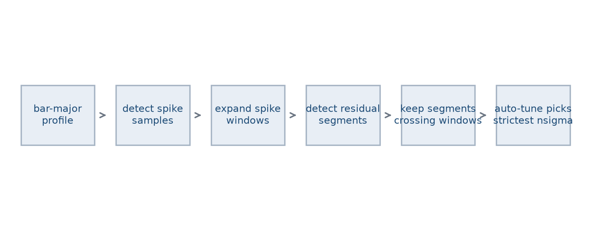
Figure 1. Overall spike-gated masking flow.

What is a spike sample?
The code inspects one profile sample at a time. A sample can become a spike only if it passes several tests: it must be finite and positive, it must not lie inside the central exclusion zone, it must be a local peak compared with its immediate neighbours, it must exceed a wider surrounding baseline, and it must drop away sharply over a short side offset.
- Candidate sample: the profile value currently being tested.
- Neighbour baseline: the median of profile samples a specified radial distance away from the candidate.
- Side samples: two nearby samples, one on each side of the candidate, used to test whether the peak is narrow.
- Expanded spike window: extra profile samples added around a detected spike so mask/profile intersections are not too brittle.

The side-drop test
The side-drop test is the most literal sharpness test. If the candidate is at index i, the code looks spike_side_offset_samples positions to the left and right. It takes the median of those two side values and requires the candidate to be brighter by spike_side_drop_fraction.
In formula form: candidate >= (1 + spike_side_drop_fraction) x median(left side sample, right side sample).
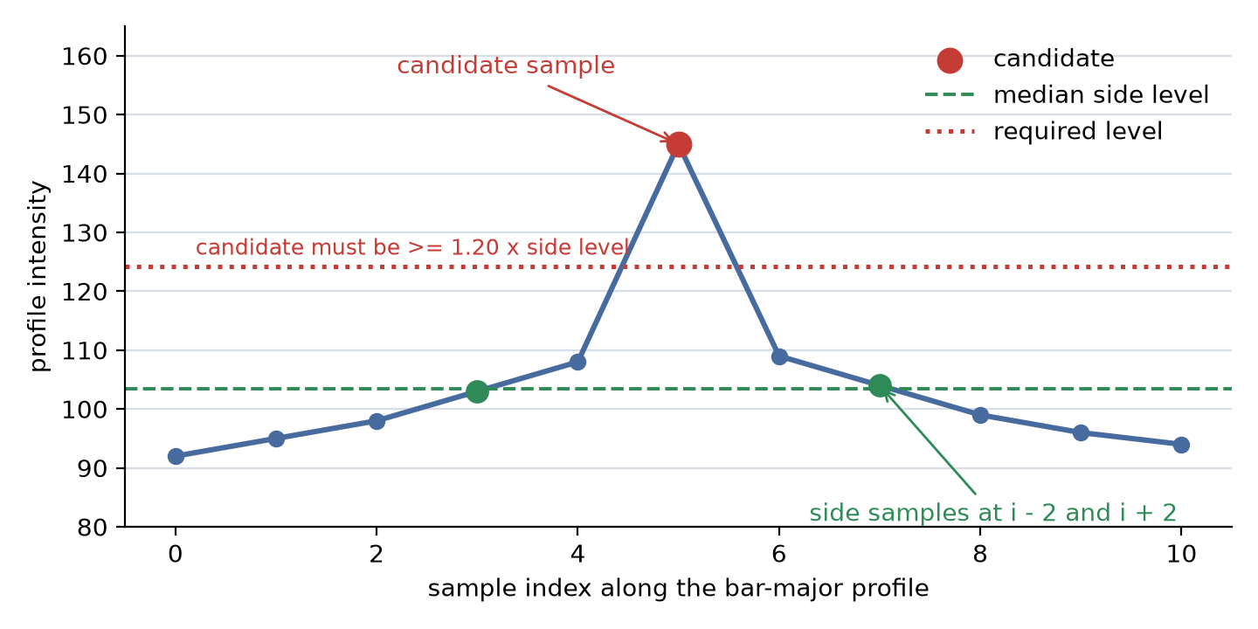
Figure 2. A candidate sample passing the side-drop test with offset = 2 and side-drop fraction = 0.20.
Quantity | Example value | Meaning
left side sample | 108 | Profile value at i - 2.
right side sample | 109 | Profile value at i + 2.
side level | 108.5 | Median of the two side samples.
side-drop fraction | 0.20 | Candidate must be 20% above the side level.
required candidate value | 130.2 | 108.5 x 1.20.
actual candidate value | 145 | Passes, because 145 >= 130.2.

Interpretation: increasing spike_side_drop_fraction demands a pointier peak; decreasing it allows broader, gentler peaks to pass.

The wider neighbour baseline
The side-drop test asks whether the peak is sharp close to the candidate. The wider neighbour-baseline test asks whether the candidate is high compared with its surrounding profile context. The code gathers samples whose distance from the candidate lies between spike_neighbour_inner_arcsec and spike_neighbour_outer_arcsec. It then requires the candidate to exceed the median of those neighbour samples by spike_excess_fraction.
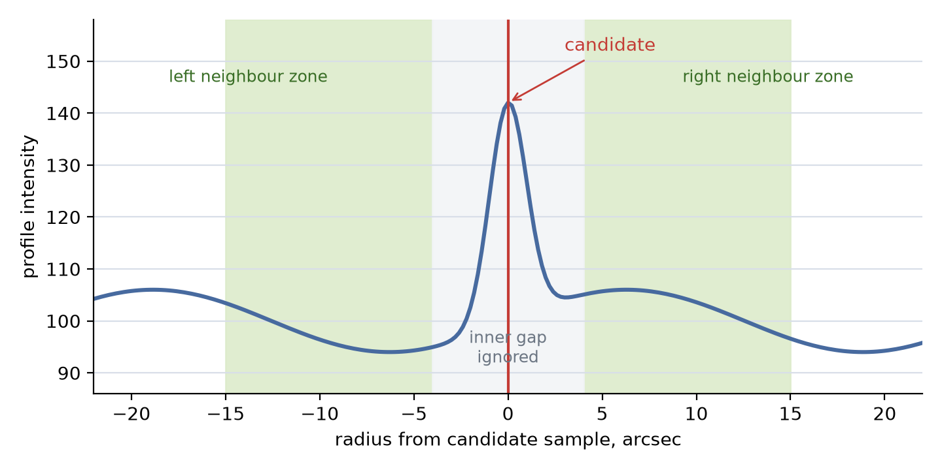
Figure 3. The inner gap is ignored; neighbour samples come from the green zones.
Quantity | Example value | Meaning
spike_neighbour_inner_arcsec | 4 arcsec | Samples closer than this are not part of the baseline.
spike_neighbour_outer_arcsec | 15 arcsec | Samples farther than this are not part of the baseline.
neighbour median | 100 | Typical surrounding profile level.
spike_excess_fraction | 0.25 | Candidate must be 25% above the neighbour median.
required candidate value | 125 | 100 x 1.25.
actual candidate value | 145 | Passes, because 145 >= 125.

Why both tests? the neighbour baseline rejects peaks that are not high relative to their wider surroundings, while the side-drop test rejects broad galaxy humps that do not fall away quickly near the candidate.

The central exclusion
The galaxy centre is often bright, structured, and steep. A central peak is therefore not good evidence for a foreground contaminant. The parameter spike_center_exclusion_arcsec defines a symmetric interval around zero radius where candidates are skipped before the spike tests are applied.
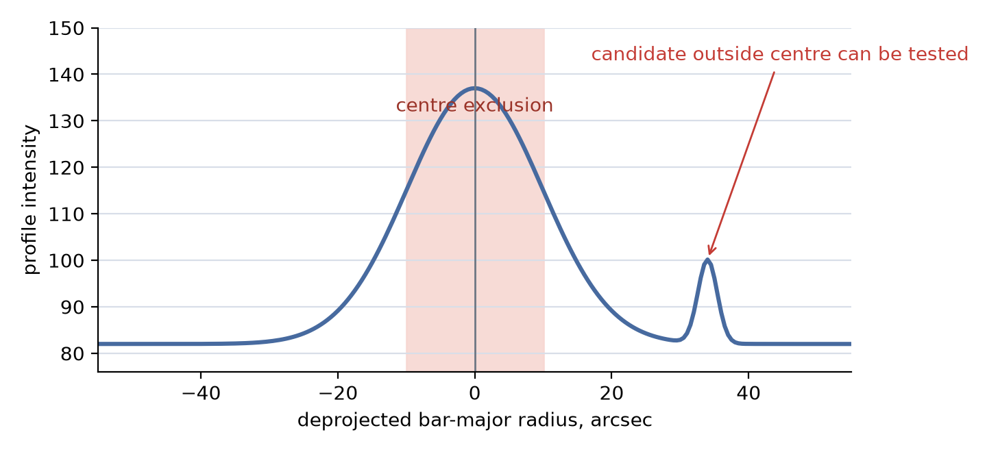
Figure 4. Candidate samples inside the centre exclusion are ignored.
Sample radius | centre exclusion | Tested?
-6 arcsec | 10 arcsec | No. abs(radius) < 10.
0 arcsec | 10 arcsec | No. This is the galaxy centre.
+8 arcsec | 10 arcsec | No. abs(radius) < 10.
+18 arcsec | 10 arcsec | Yes. It is outside the excluded centre.

Spike-window expansion and coverage
After a sample passes the spike tests, the code expands it along the one-dimensional profile by spike_window_samples. This does not create more detections in the image. It simply widens the bar-profile gate used to decide whether a residual-image segment intersects the spike.
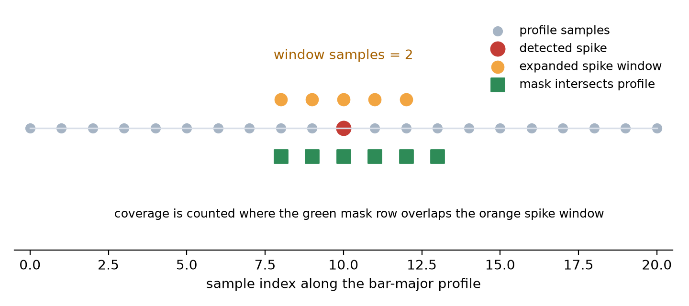
Figure 5. A detected spike sample expanded by two samples on each side.
Parameter | Example | Result
detected spike index | 10 | The profile sample that passed the spike tests.
spike_window_samples | 2 | Expand to samples 8, 9, 10, 11, and 12.
mask/profile intersection | samples 8 to 13 | The mask covers all expanded spike samples.
coverage | 5 / 5 = 1.0 | Auto-tune treats the spike samples as fully covered.

How this affects auto-tune nsigma
In spike-gated mode, auto-tune does not invent a new threshold from first principles. It tries the candidate thresholds in auto_tune_nsigmas from conservative to aggressive, usually 5.0, 4.5, 4.0, and 3.5. For each threshold it detects compact residual-image segments, filters them, keeps only segments that intersect the expanded spike samples, and measures coverage.
The selected nsigma is the first, most conservative threshold that covers essentially every detected spike sample. If the spike gate detects weaker or more numerous spikes, auto-tune may need a lower, more aggressive nsigma. If the spike gate detects only obvious sharp spikes, a higher, more conservative nsigma may be enough.
Candidate nsigma | Mask segments found? | Spike-window coverage | Auto-tune decision
5.0 | 1 segment | 60% | Not enough coverage. Try next threshold.
4.5 | 2 segments | 100% | Select 4.5, because it is the first full-coverage threshold.
4.0 | More segments | 100% | Not needed; 4.5 already worked.
3.5 | Most segments | 100% | Fallback only if stricter candidates fail.

Parameter cheat sheet
Parameter | Controls | If increased
spike_excess_fraction | How high the candidate must be above the wider neighbour baseline. | Fewer, stronger spikes pass.
spike_neighbour_inner_arcsec | How close to the candidate the baseline zone begins. | Baseline ignores more near-candidate structure.
spike_neighbour_outer_arcsec | How far from the candidate the baseline zone extends. | Baseline uses a wider radial context.
spike_side_offset_samples | How far left/right the sharpness side samples are. | Sharpness is tested over a broader local span.
spike_side_drop_fraction | How much the candidate must exceed those side samples. | Only pointier peaks pass.
spike_center_exclusion_arcsec | Radius around the galaxy centre where spike testing is skipped. | More central structure is ignored.
spike_window_samples | How many neighbouring profile samples are added around each detected spike. | Coverage becomes less brittle but more permissive.

Practical reading of the gate
A detected spike sample is therefore not just a bright point. It is a bright point that is off-centre, locally peak-like, high relative to a wider radial neighbourhood, and sharp relative to nearby side samples. The expanded spike window then turns that point decision into a small target region. The final foreground mask keeps residual-image segments only when they cross those target regions.

